Reprinted from the Soil Science Society of AmericaJournal
Volume 43, no. 5, September-October 1979
677 South Segoe Rd., Madison, WI 53711 USA

Acid Tolerance of Rhizobia in Culture and in Symbiosis with Cowpea¹

H. H. KEYSER, D. N. MUNNS, AND J. S. HOHENBERG²
ABSTRACT
In greenhouse trials, 21 strains of slow-growing rhizobia were tested for symbiotic effectiveness and ability to nodulate three varieties of cowpea, Vigna unguiculata L. Walp. in two Ultisol subsoil samples, each adjusted to pH 4.6 and pH 6.0-6.2.
The results confirmed that cowpea rhizobia contain a large and perhaps continuous variation in symbiotic tolerance of soil acidity. Some strains combined tolerance with high effectiveness.
Laboratory testing, based on ability of rhizobia to grow in acid (pH 4.5) liquid media containing Al (50 µM), successfully identified about 65% of the strains that proved symbiotically sensitive in the greenhouse trials. No highly tolerant effective strain was misidentified as sensitive. Similar simple rapid growth tests, appropriately modified, might prove useful for screening other groups of rhizobia.

Additional Index Words: nodule function, nodulation, infection, tropical legumes.

Keyser, H. H., D. N. Munns, and J. S. Hohenberg. 1979. Acid tolerance of rhizobia in culture and in symbiosis with cowpea. Soil Sci. Soc. Am. J. 43:719-722.

R HIZOBIAL STRAINS are known to differ in ability to grow in acid soils and culture media (Munns, 1977, 1978). More important are differences in "symbiotic acid tolerance," ability to sustain satisfactory growth of the dinitrogen-dependent host plant despite acid-related stress in the soil. Amongst strains of rhizobia tested on Pisum sativum, Lie (1971) observed variation in performance at pH 4.6 that was unrelated to effectiveness at neutral pH. Similar variation in symbiotic tolerance of acidity, independent of effectiveness at favorable pH, appeared in trials with 40 strains of rhizobia of the cowpea group tested on soil-grown plants of two varieties of Vigna radiata, mung (Munns, et al-., 1979). Some strains possessed the valuable combination of high effectiveness and high symbiotic tolerance of soil acidity. This paper describes similar greenhouse screening of cowpea rhizobia for symbiotic acid tolerance, with different acid soils and a different host species, Vigna unguiculata L. Walp., cowpea.
The main purpose was to test a rapid laboratory method of prescreening rhizobia for tolerance of soil acidity, potentially valuable for reducing the number of strains going to more cumbersome greenhouse screening. We supposed that many symbiotically acid-sensitive strains fail in acid soil simply because they cannot grow and colonize the host rhizosphere, let alone complete later acid-sensitive steps in symbiotic establishment. We also supposed that Al toxicity would be a significant factor, since cowpea can nodulate in very acid soils. Given these suppositions, symbiotic failure of many strains in acid soil should be
'Contribution from Dept. of Land, Air and Water Resources, Univ. of Calif. Davis, CA 95616. Supported by grants from the U.S. Agency for Int. Dev. and N.S.F. Received 13 Nov. 1978. Approved 19 Mar. 1979.
'Post Graduate Research Scientist, Professor, and Graduate Research Assistant, respectively.
predictable from their inability to grow in a defined medium at, pH 4.5 with 50 AM Al (Keyser and Munns, 1979x). To be successful, this laboratory screening should eliminate a large proportion of symbiotically sensitive strains but few of the strains that remain highly effective at low pH.
MATERIALS AND METHODS Rhizobia
Sources and identity of the rhizobia have been listed elsewhere (Munns, et al., 1979). For convenience, we omit letter prefixes to strain identification numbers. Strain 68 (= IQ68-5) came from Iraq Ministry of Agriculture via University of Hawaii NifTAL Project, Paia, Hawaii. Strains 756 and 1024 (prefix CB) came from CSIRO Cunningham Lab., Brisbane, Queensland. Strains n9, n10, n15 and n16 (prefix 316) cam.: from USDA, Beltsville, Maryland. The others (prefix TAL) came from NifTAL, some of them originating with The Nitragin Co., Milwaukee, Wisconsin.
Greenhouse Trials
There were two greenhouse trials. In the first, 12 strains of rhizobia were tested on V. unguiculata 'California Blackeye 5' (BE5) on subsoil material from Goldridge fine sandy loam from Sebastapol, California. In the second trial, the same 12 strains and 9 others were tested on varieties 'TVull90' and 'TVu4557', using subsoil material from Josephine clay loam from Calaveras, California. In both trials, each strain was tested at soil pH 4.6 and 6.0-6.2 (aqueous paste). Uninoculated controls and NH₄NO₃-fertilized controls were included with each soil and pH level. There were three replicates in randomized blocks. Each replicate pot received five seeds of a variety, thinned to three plants in the first trial, and to two of each variety in the second trial.
Both soils had predominately kaolinite and oxide clay minerals, and less than 0.1% organic matter. Table 1 lists cation analyses and U.S. Taxonomy classification. The Goldridge material had an unadjusted saturation paste pH of 4.6. For the high-pH treatment this was raised to 6.0 with 9 meq CaCO₃/ kg soil. The Josephine's natural pH of 5.4 was lowered to 4.6 with 23 meq Al₂(SO₄), per kg soil, and raised to 6.2 with 10.6 meq CaCO, per kg soil. Each pot received 1.9 kg soil, and basal fertilizers supplying, per kg soil, 2 mmol K₂SO₄, 10 mg Zn, 0.1 mg Mo for both soils, and 5 mmol KH₂PO₄ for Goldridge soil or 12 mmol KH₂PO₄ for Josephine. After mixing and watering, pots were left 3 weeks, then checked with a pH meter for uniformity and completeness of reaction.
719
Seed of BE5 was obtained from Mr. C. L. Tucker, Dept. of Agronomy and Range Science, University of California, Davis. Seed of TVu1190 and TVu4557 was obtained from The International Institute of Tropical Agriculture, Ibadan, through the NifTAL Project, Hawaii. Before planting, seed was surface sterilized by 5 minutes' submergence in 30% H₂0₂ followed by several rinses in sterile water.
For inoculation, rhizobial cultures on yeast mannitol agar slants were suspended and diluted in 1 mM CaC1₂ + 1 mM MgSO₄ and pipetted onto seed in pots immediately before covering. Viable counts indicated that each seed each received between 10^{4.7} and 10^{5.1} cells in the first trial and between 10^{5.4} and 10^{6.4} in the second.
Ammonium nitrate was applied to +N controls in two applications of 6 mmol per pot (88 ppm N), 1 week and 2 weeks after planting.
Greenhouse soil temperature varied between 29°C (day) and 21°C (night). Pots received distilled water daily to keep soil between 75% and 100% field capacity. Plant color and size differences were observed daily. At 45 days in the first trial and at 42 days in the second, plants were washed out of the soil, bagged in plastic and refrigerated until determination of nodule number, nodule fresh weight, and shoot dry weight.
Data were transformed [log x or log (1 + x)] where necessary before analysis of variance.

Laboratory Screening for Growth in Acid Media

All the rhizobia were inoculated from slants to provide a low initial density (10³ to 10⁴ viable cells per ml) in glutamatemannitol-salts liquid media at pH 6, at pH 4.5, and at pH 4.5 with 50 µM Al. Growth was assessed by the achievement of turbidity (10⁷ cells per ml) within 25 days of inoculation. Details are given by Keyser and Munns (1979a) along with evidence that the procedure measures growth capability with adequate maintenance of pH and Al stress levels. Calcium deficiency and Mn toxicity at realistic levels (50 and 200 µM respectively) had little adverse influence on growth rates of these rhizobia (Keyser and Munns, 1979b).

RESULTS AND DISCUSSION

Nodulation, Plant Growth, and Nitrogen Fixation

Growth of plants without N-fertilizer depended on effective nodulation, and for the purpose of these trials, yield is an adequate measure of fixation. In both greenhouse trials, plants became yellow 1 week after emergence. Plants with N-fertilizer or effective inoculants became green again at the second trifoliate leaf stage, about 14 days after emergence in limed soil and 17 days in unlimed soil. Without N-fertilizer, sparsely or ineffectively nodulated plants grew little beyond this stage, remained yellow, and had < 2% N, 5 to 7 mg N per plant, in shoots. With highly effective nodulation, shoot N content was 120 to 140 mg N per plant for BE5 and TVu1190, 45 to 50 mg/plant for TVu4557.
Acidity, which probably entailed Al toxicity in the Josephine soil (Table 1), had little effect on growth of N-fertilized plants, but reduced growth and nodulation of symbiotically-dependent plants to a degree depending markedly on rhizobial strain, and somewhat on soil type and host variety (Fig. 1, 2 and 3).
At the favorable pH of 6.0-6.2, all the rhizobia produced abundant nodulation (Fig. lb, 2b, 3b), and were all effective on TVu4557 and 1190 (Fig. la, 2a, 3a). The latter point is not established with certainty by the data presented (Fig. 2 and 3) because the sample of Josephine soil proved to contain rhizobia that established significant and moderately effective nodulation in the uninoculated controls at the favorable pH. However, yield and nodulation data similar to those shown for pH 6.2 in Fig. 2 and 3 had been obtained
2 SOIL SCI. SOC. AM. J., VOL. 43, 1979
from a preliminary test of all the strains in a sample of the Josephine soil at pH 6.3, in which uninoculated controls remained unnodulated.
In most cases, reduction of plant growth by acidity corresponded with reduction in nodule number. Reduction of nodule number by acidity, though, was partly compensated by increase in average nodule size. Fresh weight per nodule enlarged by a factor of 2.5 to 4 on TVu4557 and by a factor of 1.5 to 2 on TVu1190. Thus, because of greater compensation in 4557, plant growth was perhaps no more acid-sensitive than in TVu1190 despite the more severe reduction of nodule number in the former (compare Fig. 2 and 3).
In general, the data confirm that cowpea rhizobia contain a large and perhaps continuous variation in symbiotic tolerance of soil acidity. Some strains combined tolerance with effectiveness in these trials, as well as in previous trials with Vigna radiata (Munns, et al., 1979). These desirable strains included 174, 209, 420 and 425. Other strains proved highly acid-sensitive on both species and on both soils. These included 68,207, and 1024.

Correspondence with Laboratory Prescreening

Prescreening, based on ability to grow in acid medium containing Al, would have successfully eliminated about 65%. of the strains that proved symbiotically acid-sensitive in soil, while erroneously eliminating only one effective tolerant strain (Fig. 1, 2, 3). That
one strain, n15 in association with variety 'TVu4557', was poorly effective and barely classified as tolerant (Fig. 3b). Similar simple laboratory screening might prove useful for other groups of rhizobia, with appropriate modification of the kind and severity of stress.
Not all symbiotically acid-sensitive rhizobia were correctly identified by the laboratory prescreening (Fig. 2, 3). Improvement may be possible; but even so, error of this kind is acceptable, and is to be expected because artificial media are not like soils, and because rhizobial growth in the soil is only one of the acid-sensitive events in establishment and function of the symbiosis.
Even when the host rhizosphere contains enormous numbers of viable infective rhizobia, low pH can prevent infection of the host plant (Lie, 1969, 1971; Munns, 1968). Aluminum may exert a similar specific inhibition of infection or nodule initiation in acidtolerant legumes, as shown for Stylosanthes spp (M. M. de Carvalho, Ph.D. Thesis, University of Queensland, 1978). Failure during infection may therefore explain why some strains failed to nodulate at pH 4.6 despite ability to grow well in the acid laboratory medium. Perhaps a high proportion of strains failed in this way in previous trials with V. radiata at pH 5.0 (Munns et al., 1979).
Function of established nodules can also be inhibited by acidity, depending perhaps on host as well as rhizobial genotype (Munns, 1977, 1978). This may explain why, with some strains, growth of the plant was reduced by acidity although nodulation was not. Exam-
KEYSER ET AL.: ACID TOLERANCE OF RHIZOBIA IN CULTURE AND SYMBIOSIS WITH COWPEA
721
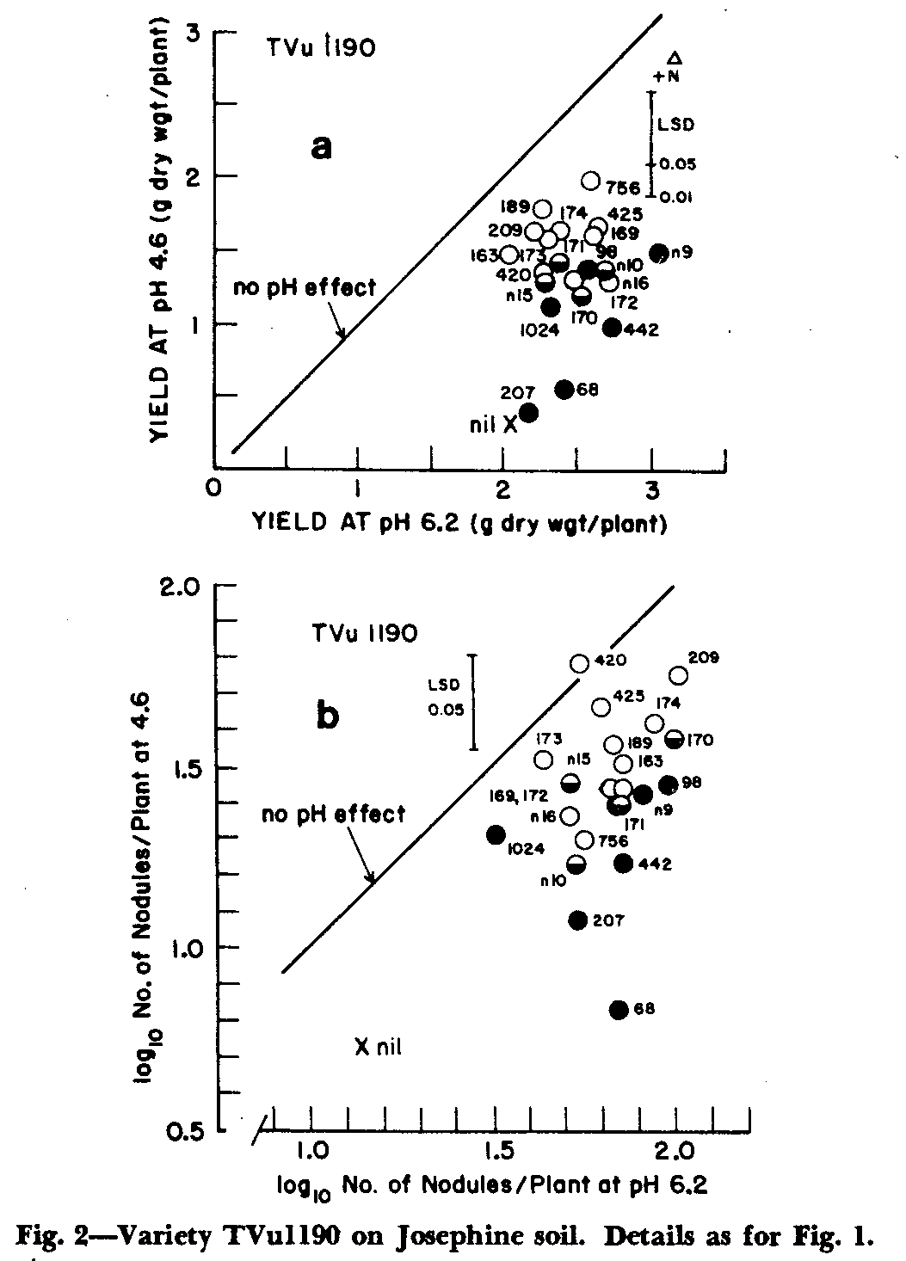
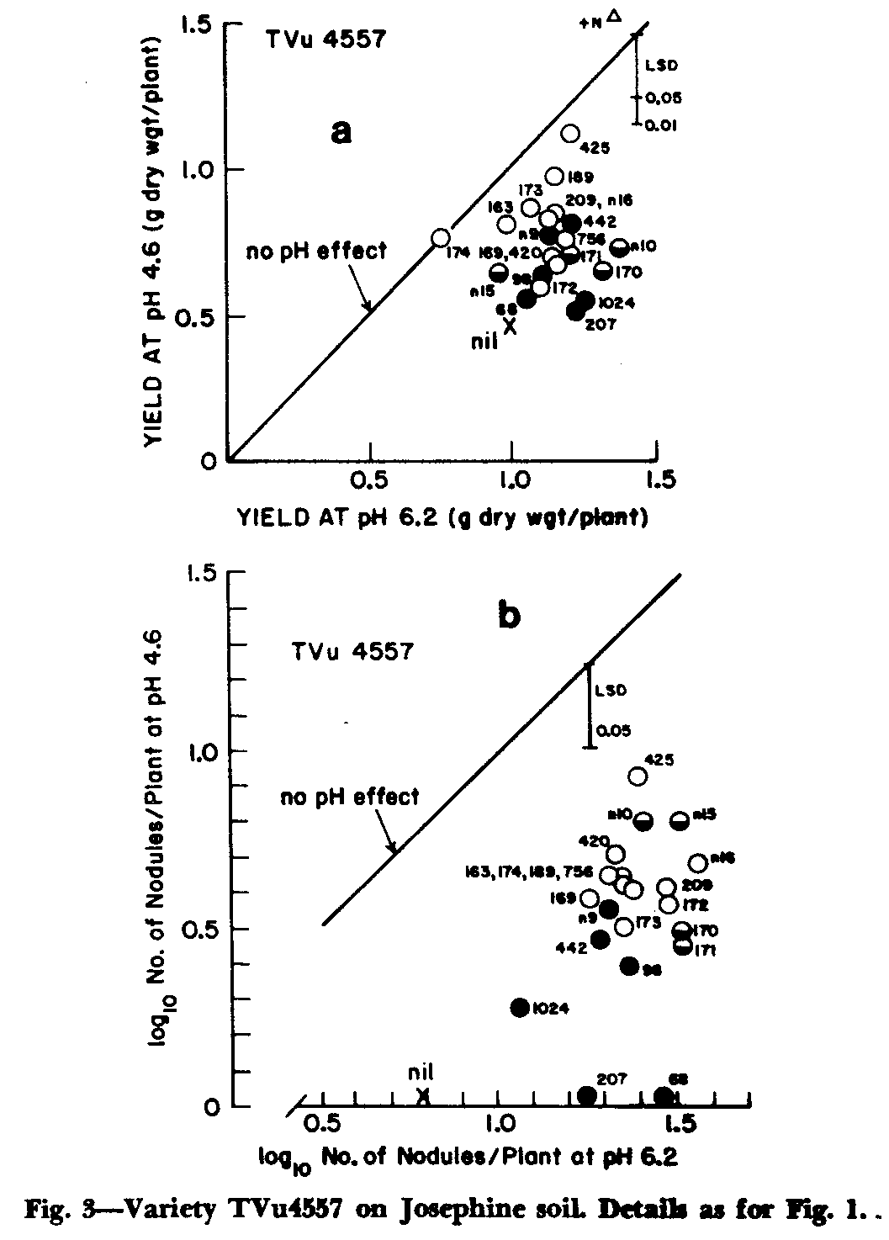
ples are strains 169, 170, and 189 on BE5 (Fig. 1), and 420 and 425 on TVu1190 (Fig. 2).
The above exceptions apart, most of the strains that failed in the greenhouse trials at low soil pH probably failed because of inability to multiply in soil, even though the inoculum levels were high compared with common field practice. In the low-Al Goldridge soil, strains whose nodulation of BE5 was most severely inhibited by soil acidity were acid-sensitive: acid-tolerant but Al-sensitive strains did as well as strains tolerant of both factors (Fig. lb). The Josephine soil had levels of Al normally high for a soil of pH 4.6 (Pearson, 1975); and here only strains tolerant of both acidity and Al proved symbiotically tolerant of the soil acidity (Fig. 2 and 3). Sensitivity to Al seems common amongst otherwise acid-tolerant cowpea rhizobia (Keyser and Munns, 1979a). The data imply that both Al and acidity are potent inhibitors of nodulation through their effects on rhizobial growth. A strain's sensitivity in this respect can readily be determined in the laboratory.
ACKNOWLEDGEMENT
We are grateful to Timothy Righetti and David Tauter for technical assistance, and to J.C. Burton, R. A. Date, D. F. Weber, T. L. Wacek, and V. V. Reyes for supplying rhizobia.
LITERATURE CITED
1. Keyser, H. H. and D. N. Munns. 1979a. Tolerance of rhizobia to acidity, aluminum, and phosphate. Soil Sci. Soc.
4 SOIL SCI. SOC. AM. J., VOL. 43, 1979
Am. J. 43:519-523. bium symbiosis in tropical agriculture. Univ. Hawaii Coll.
2. Keyser, H. H. and D. N. Munns. 1979b. Effects of Ca, Mn, Trop. Agr. Misc. Publ. 145.
and Al on growth of rhizobia in acid media. Soil Sci. Soc. 7. Munns, D. N. 1978. Soil acidity and nodulation. p. 247
Am. J. 43:500-503. 264. In C. S. Andrew and E. J. Kamprath (ed.). Mineral
3. Lie, T. A. 1969. Effects of low pH on different phases of nutrition of legumes in soils of the tropics and subtropics.
nodule formation in pea plants. Plant Soil 31:391-406. C.S.I.R.O., Melbourne.
4. Lie, T. A. 1971. Symbiotic N fixation under stress condi- 8. Munns, D. N., H. H. Keyser, V. W. Fogle, J. S. Hohenberg,
tions. Plant Soil, Spec. Vol. 1971:117-127. T. L. Righetti, D. L. Lauter, M. G. Zaroug, K. L. Clarkin and
5. Munns, D. N. 1968. Nodulation of Medicago sativa in solu- K. A. Whitacre. 1979. Tolerance of soil acidity in symbioses
tion culture: Acid-sensitive steps. Plant Soil 28:129-146. of Vigna radiata with rhizobia. Agron. J. 71:256-260.
6. Munns, D. N. 1977. Soil acidity and related factors. p. 211- 9. Pearson, R. W. 1975. Soil acidity and liming in the humid
236. In J. M. Vincent (ed.). Exploiting the legume rhizo- tropics. Cornell Int. Agric. Bull. 30.

